**MAHENDRA ENGINEERING COLLEGE FOR WOMEN**

**DEPARTMENT OF INFORMATION TECHNOLOGY**



**PROFESSIONAL READINESS FOR INNOVATION, EMPLOYABILITY**

**AND ENTREPRENEURSHIP- IBM NALAIYA THIRAN**

**PROJECT REPORT**

**TITLE-POWERED NUTRITION ANALYZER FOR FITNESS ENTHUSIASTS**

**TEAM ID:PNT2022TMID30379**

**BY**

|  |  |
| --- | --- |
| **M RAMYA** | **611419104060** |
| **D RAMALAKSHMI** | **611419104059** |
| **G PUSPALATHA** | **611419104057** |
| **M SUNITHA** | **611419104090** |

**TABLE OF CONTENTS**

1. **INTRODUCTION**
   1. Project Overview
   2. Purpose
2. **LITERATURE SURVEY**
   1. Existing problem
   2. References
   3. Problem Statement Definition
3. **IDEATION & PROPOSED SOLUTION**
   1. Empathy Map Canvas
   2. Ideation & Brainstorming
   3. Proposed Solution
   4. Problem Solution fit
4. **REQUIREMENT ANALYSIS**
   1. Functional requirement
   2. Non-Functional requirements
5. **PROJECT DESIGN**
   1. Data Flow Diagrams
   2. Solution & Technical Architecture
   3. User Stories
6. **PROJECT PLANNING & SCHEDULING**
   1. Sprint Planning & Estimation
   2. Sprint Delivery Schedule
   3. Reports from JIRA
7. **CODING & SOLUTIONING (Explain the features added in the project along with code)**
   1. Feature 1
   2. Feature 2
   3. Database Schema (if Applicable)
8. **TESTING** 
   1. Test Cases
   2. User Acceptance Testing
9. **RESULTS**
   1. Performance Metrics
10. **ADVANTAGES & DISADVANTAGES**
11. **CONCLUSION**
12. **FUTURE SCOPE**
13. **APPENDIX**

Source Code

GitHub & Project Demo Link

1. **INTRODUCTION**

**1.1 PROJECT OVER VIEW**

Diet and eating habits have a significant role in enhancing lifestyle by preventing diseases. The food industry is complex, and the path from idea generation to commercialization for innovations in the food sector is lengthy. According to reports, nutrition has a big impact on how CNCD (chronic non-communicable diseases), such obesity, depression, and cardiovascular disease, progress. Furthermore, before introducing new product concepts to consumers, careful data must be gathered, tested, and certified. If this task is done manually, there is a great chance that mistakes will be made, which will ultimately result in time and money being wasted with no positive results. Here, **AI in nutrition has a big impact by providing the amazing potential** for illness prevention and improved medical care.

Traditional methods for capturing data and calculating statistics were laborious and prone to human error; fortunately, disruptive digital technologies entered the picture and effectively recorded data and computed mission-based statistics. A solid foundation for using historical data to improve the following generation is provided through transformation. In nutrition, artificial intelligence and machine learning analyze raw data to uncover competitive traits that are useful for forecasting better nutritional regimens. As mentioned, AI in nutrition optimizes four essential tasks:

**Science of Food:** By conducting in-depth market analyses, AI automates recipe creation and enforces safety standards.

**Distribution & Supply Chain:** Predictive analytics in nutrition aid in reducing waste, saving money, visual pattern identification, agile forecasting, and accuracy.

* The user interacts with the **UI (User Interface)** and give the image as input.
* Then the input image is then pass to our **flask application**.
* And finally with the help of the model which we build we will classify the result and showcase it on the UI.
  1. **PURPOSE**

The primary goal of the project is to develop a model that will be used to categorize fruits according to their various attributes, such as color, shape, and texture. Here, users can take pictures of various fruits, which are subsequently uploaded to a trained algorithm for analysis. The algorithm examines the image and determines the nutritious content of fruits such (Sugar, Fiber, Protein, Calories, etc.)

In India, this global trend has had a positive impact on scores of startups and websites catering to this segment. AI and its various subsets have been leveraged by these platforms to identify the calorie intake and also to make food recommendations for a healthy diet. In most cases, what we see is that these platforms act as a data repository where while providing **real-time information to its users**, it also makes available to numerous clients who work in this field for a determined rate.

Precision medicine is another field where AI helps with individual variability in genes and lifestyle. Precision medicine is significantly improved due to the development of the major biologic database, patient characterization methods, and smart technology involvement. Healthcare providers depend on computational tools as these are trained on previous related information, and their electronically generated decisions help them decide on better treatment strategies. AI in precision medicine learns and develops a relationship among variables to create an input-output mapping known as data interpretation.

Several companies are experimenting to explore machine learning’s remarkable capabilities in relation to improving the existing applications. Plenty of nutrition apps are currently available with variable accuracy.Because subjects must adhere to diets for years and because there is a large potential for human error, randomized trials have proven challenging to conduct in the field of nutrition. The development of artificial intelligence has, however, made it possible for researchers to evaluate large data sets, producing a complete picture of a person's health indicators, including the variables that affect their particular dietary demands.

1. **LITERATURE SURVEY**

**2.1 EXISTING SURVEY**

Food is essential for human life and has been the concern of many healthcare conventions. Nowadays new dietary assessment and nutrition analysis tools enable more opportunities to help people understand their daily eating habits, exploring nutrition patterns and maintain a healthy diet. Nutritional analysis is the process of determining the nutritional content of food. It is a vital part of analytical chemistry that provides information about the chemical composition, processing, quality control and contamination of food.

The main aim of the project is to building a model which is used for classifying the fruit depends on the different characteristics like colour, shape, texture etc. Here the user can capture the images of different fruits and then the image will be sent the trained model. The model analyses the image and detect the nutrition based on the fruits like (Sugar, Fibre, Protein, Calories, etc.).

* 1. **REFERENCES**

1. **<https://aihints.com/artificial-intelligence-in-nutrition-ai-hints/>**
2. **<https://analyticsindiamag.com/5-ai-powered-nutrition-apps-that-help-fitness-enthusiasts-with-their-calorie-intake/>**
3. **<https://thinkml.ai/ai-in-nutrition-top-10-fitness-apps-and-startups/>**
4. **<https://www.researchgate.net/figure/Artificial-intelligence-AI-powered-photo-analysis-of-a-meal-Deep-learning-AI-analyzes_fig1_331798832>**
5. **<https://pdfs.semanticscholar.org/5c52/6d51fba02228122897518e6679b85067dc13.pdf>**
   1. **PROBLEM STATEMENT DEFINITION**

The term “artificial intelligence” was first proposed in 1955 by the American computer scientist John McCarthy (1927–2011) in the proposal of a research project, which was carried out the following year at Dartmouth College in Hanover, New Hampshire . Artificial intelligence (AI) as a branch of computer science, the purpose of which is to imitate thought processes, learning abilities and knowledge management, finds more and more applications in experimental and clinical medicine. In recent decades, there has been an expansion of AI applications in medicine and biomedical sciences. The possibilities of artificial intelligence in the field of medical diagnostics, risk prediction and support of therapeutic techniques are growing rapidly. Thanks to the use of AI in ophthalmological , radiological and cardiac diagnostics, measurable clinical benefits have been obtained. AI was used in research on new pharmaceuticals . The development of AI also provides new opportunities for research on nutrients and medical sensing technology

* A web based application that allows user to retrieve the nutritional facts of a food item by adding an image of it.
* Making a user-friendly interface and making it all platform compatible.
* Providing rewards for usage and sharing of application.
* Using client data and feedback to improvise.

Collaborating with other parties for larger scale usage

1. **IDEATION & PROPOSED SOLUTION**

**3.1 EMPATHY MAP CANVAS**

This is the Empathy Map Canvas proposed for the project. An empathy map is a collaborative tool teams can use to gain a deeper insight into their customers. Much like a user persona, an empathy map can represent a group of users, such as a customer segment. The empathy map was originally created by Dave Gray and has gained much popularity within the agile community.

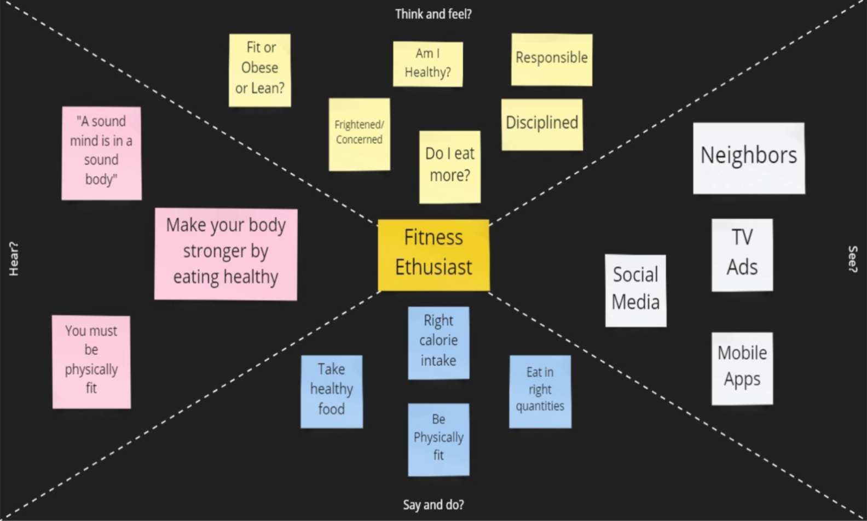

* 1. **IDEATHON AND BRAINSTORMING:**

This is the Empathy Map Canvas proposed for the project.

An ideathon is a short, intensive, workshop-like experience for students to address some of the most pressing challenges of our time. Participants work in teams and use design thinking and innovative learning practices to ideate and collaborate on possible solutions.

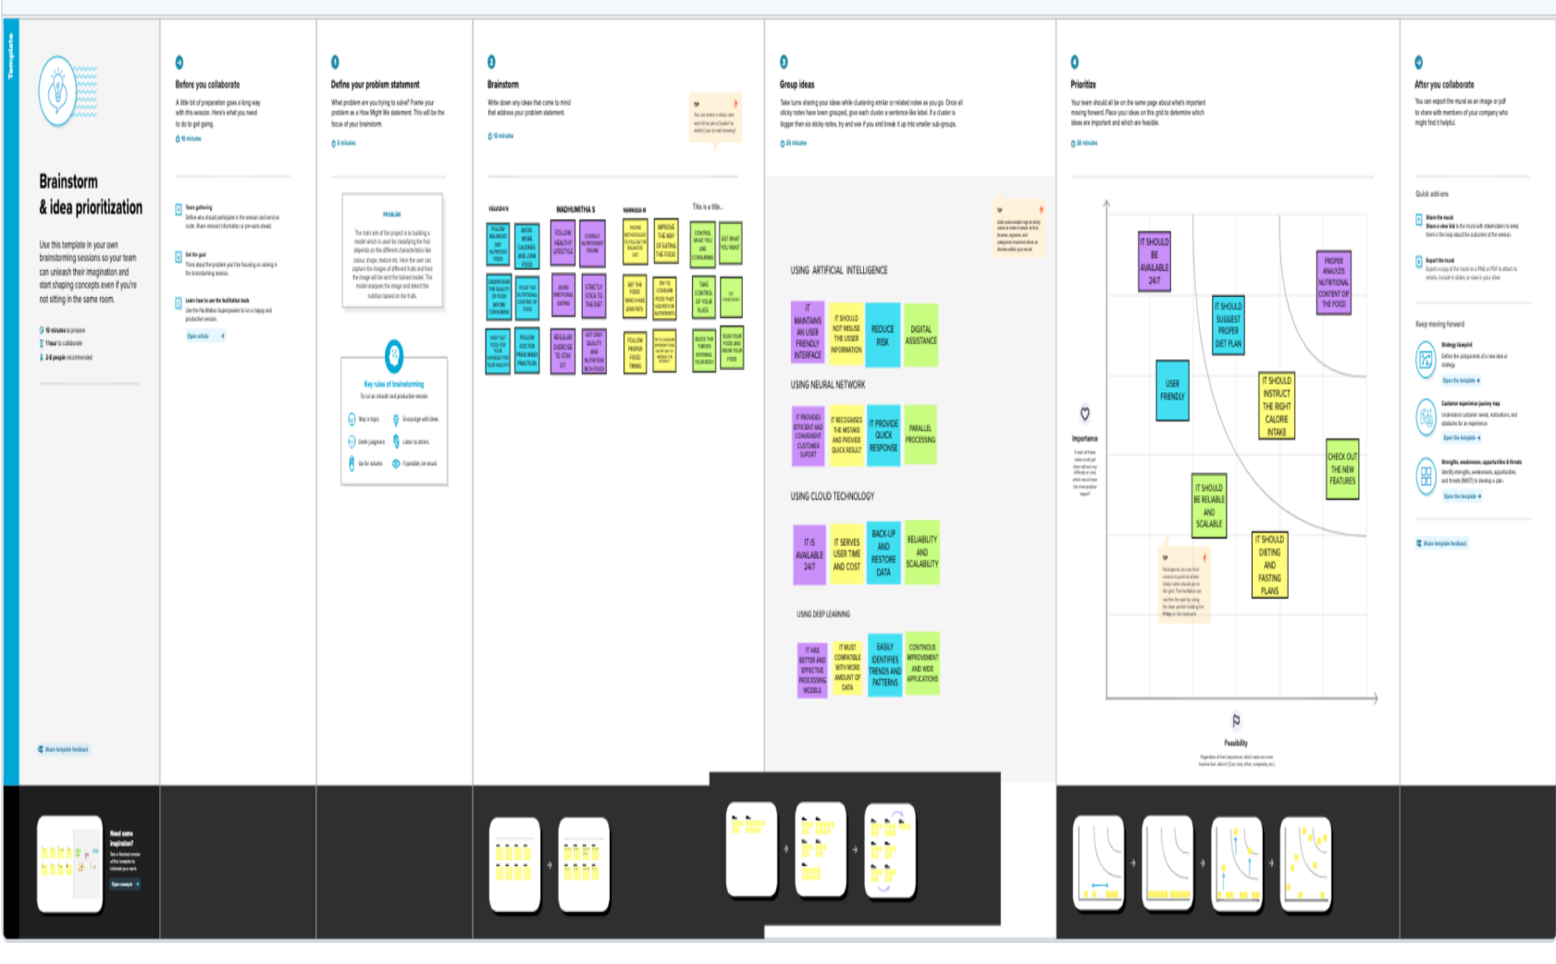

* 1. **SOLUTION FIT AND ARCHITECHRURE**

Solution, Design and Architecture (SD&A) is an in-depth IT scoping and review process that bridges the gap between your current IT environments, technologies, and your business needs in order to deliver maximum return-on-investment and determine the steps required in order to get there.

A solution architecture (SA) is an architectural description of a specific solution. SAs combine guidance from different enterprise architecture viewpoints (business, information and technical), as well as from the enterprise solution architecture (ESA).

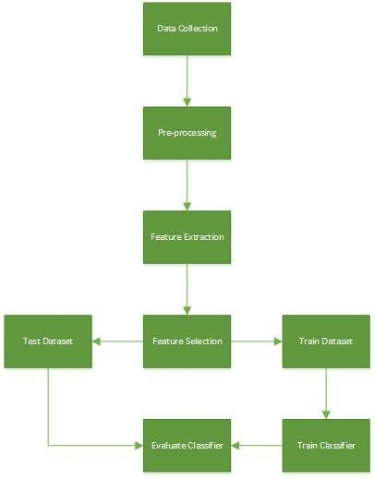

1. **REQUIREMENT ANALYSIS:**

**4.1 FUNCTIONAL REQUIREMENT:**

Functional requirements may involve calculations, technical details, data manipulation and processing, and other specific functionality that define what a system is supposed to accomplish. Behavioral requirements describe all the cases where the system uses the functional requirements, these are captured in use cases.

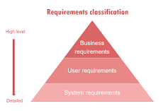

The list of examples of functional requirements includes:

Business Rules.

Transaction corrections, adjustments, and cancellations.

Administrative functions.

Authentication.

Authorization levels.

Audit Tracking.

External Interfaces.

* 1. **NON- FUNCTIONAL REQUIREMENT:**

Nonfunctional Requirements (NFRs) define system attributes such as security, reliability, performance, maintainability, scalability, and usability. They serve as constraints or restrictions on the design of the system across the different backlogs.

1. **PROJECT DESIGN**
   1. **DATA FLOW DIAGRAMS:**

A data flow diagram (DFD) is a graphical or visual representation using a standardized set of symbols and notations to describe a business's operations through data movement. They are often elements of a formal methodology such as Structured Systems Analysis and Design Method (SSADM).

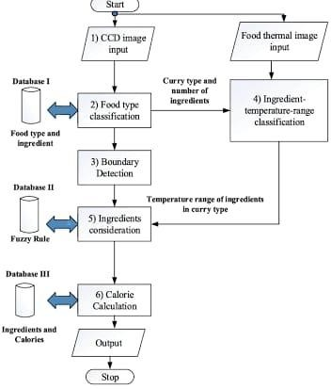

* 1. **Solution & Technical Architecture:**

Solution Architects are most similar to project managers, ensuring that all parties, including stakeholders, are on the same page and moving in the right direction at all stages. Technical architects manage all activities leading to the successful implementation of a new application.

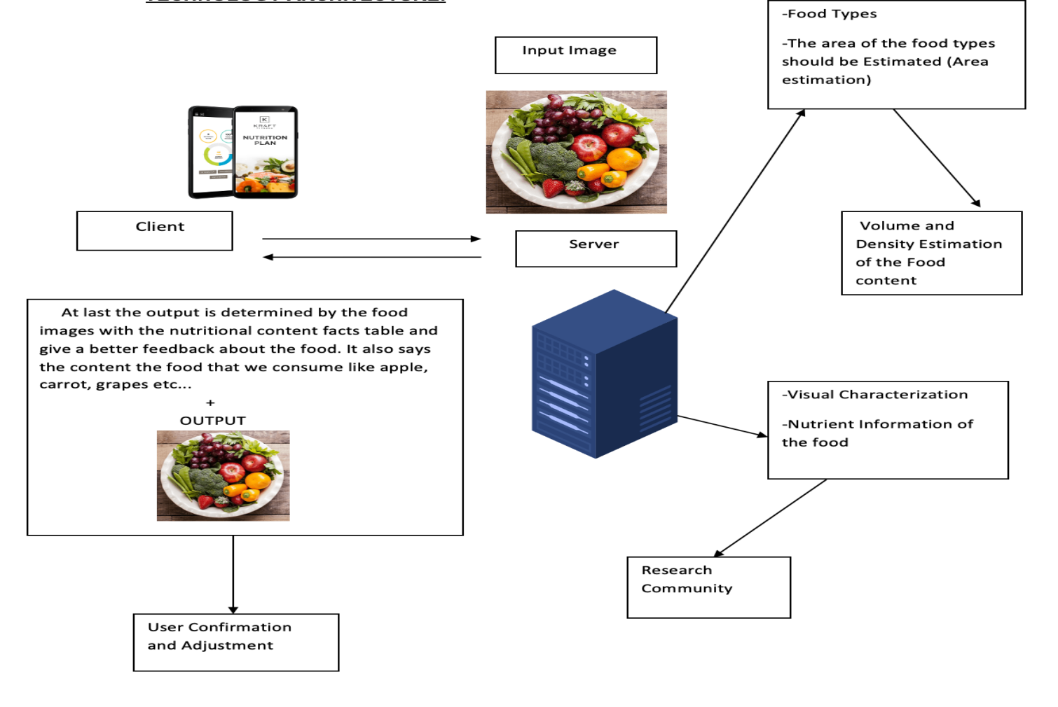

* 1. **User Stories:**

A user story is an informal, general explanation of a software feature written from the perspective of the end user or customer. The purpose of a user story is to articulate how a piece of work will deliver a particular value back to the customer.

A key component of agile software development is putting people first, and a user story puts end users at the center of the conversation. These stories use non-technical language to provide context for the development team and their efforts. After reading a user story, the team knows why they are building, what they're building, and what value it creates.

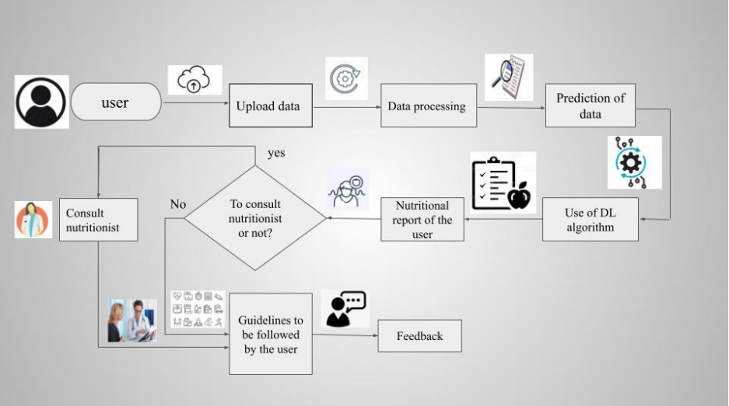

**6. PROJECT PLANNING & SCHEDULING**

**6.1 Sprint Planning & Estimation**

SPRINT1

* + Data collection
  + Image processing

SPRINT2

* + Model Building

SPRINT3

* + Application Building

SPRINT4

* + Register on IBM Cloud
  + Train the model

**DATASET:**

* **https://drive.google.com/drive/folders/1zpnSFRUQNazuPj95mSAIz0dLj-Ekk8AG**

**6.2 Sprint Delivery Schedule:**

A sprint is a short, time-boxed period when a scrum team works to complete a set amount of work. Sprints are at the very heart of scrum and agile methodologies, and getting sprints right will help your agile team ship better software with fewer headaches.

Sprints are time-boxed periods of one week to one month, during which a product owner, scrum master, and scrum team work to complete a specific product addition. During a sprint, work is done to create new features based on the user stories and backlog. A new sprint starts immediately after the current sprint ends

**7. CODING & SOLUTIONING(Explain the features added in the project along with code)**

* 1. 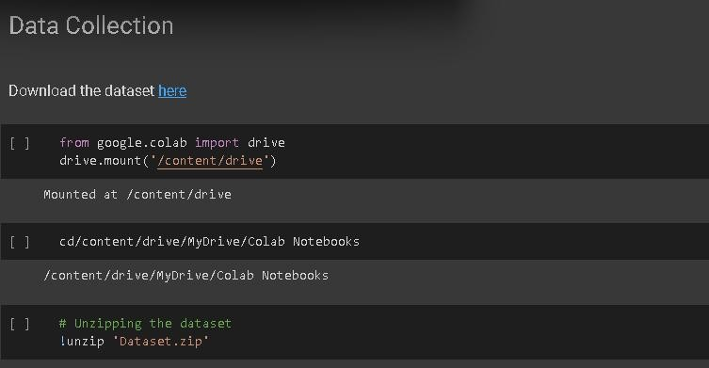**Feature1**

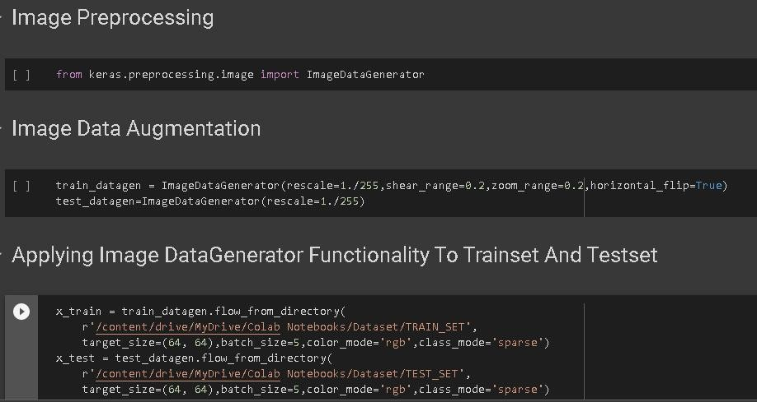

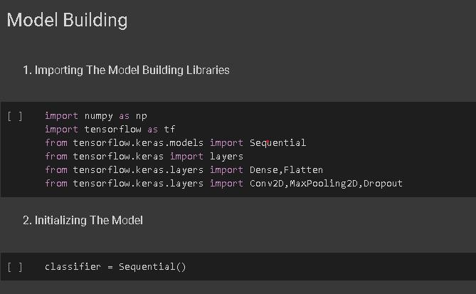

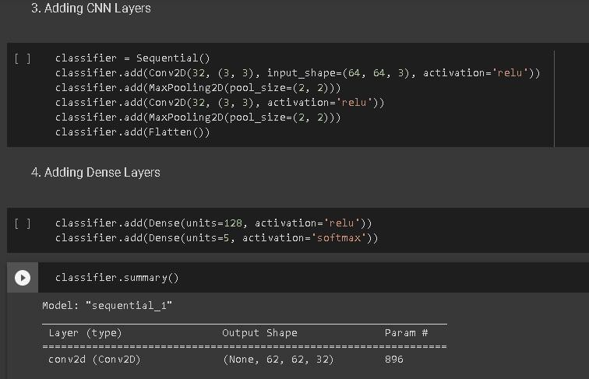

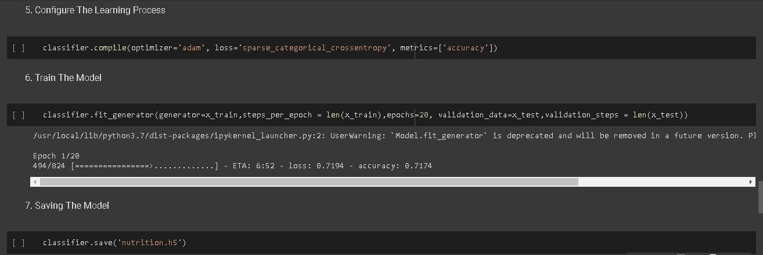

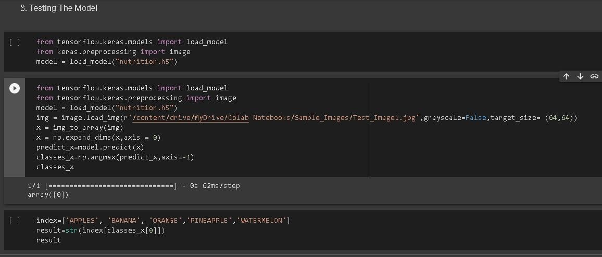

* 1. **Feature 2**

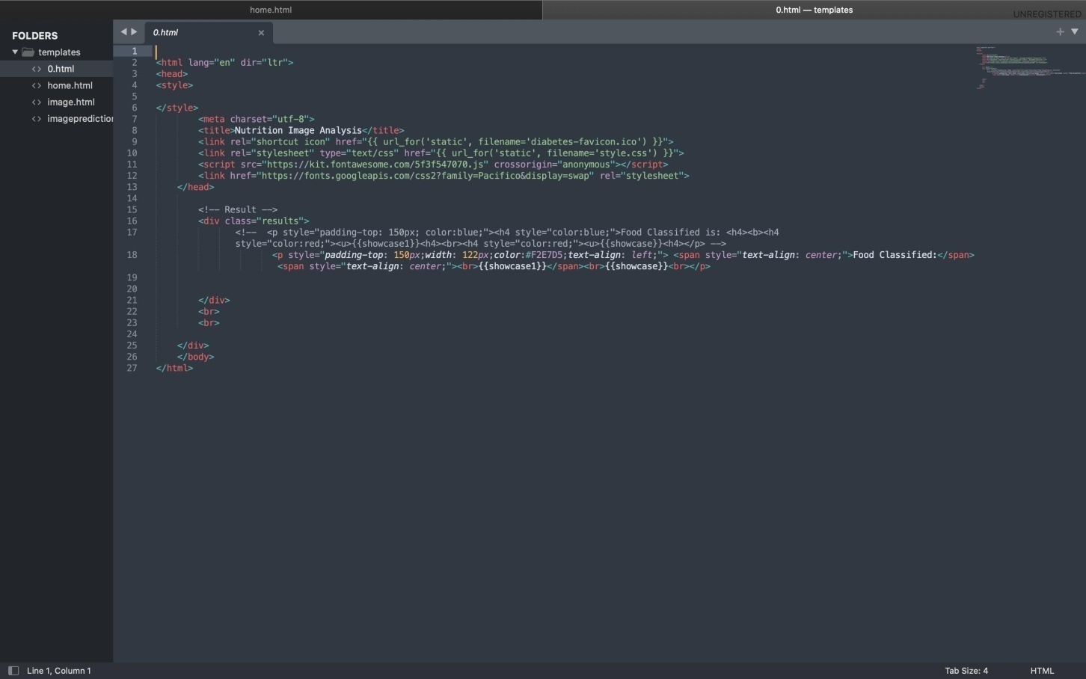

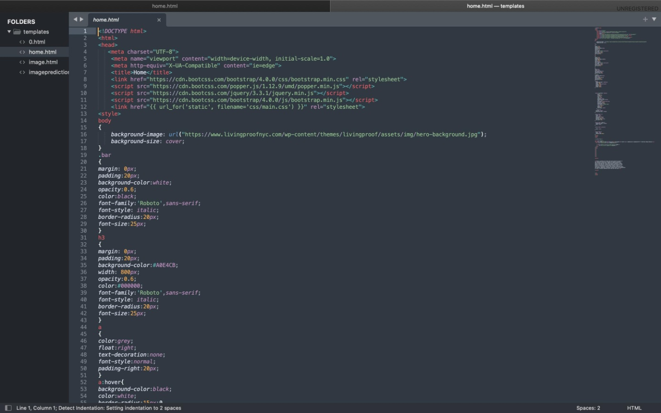

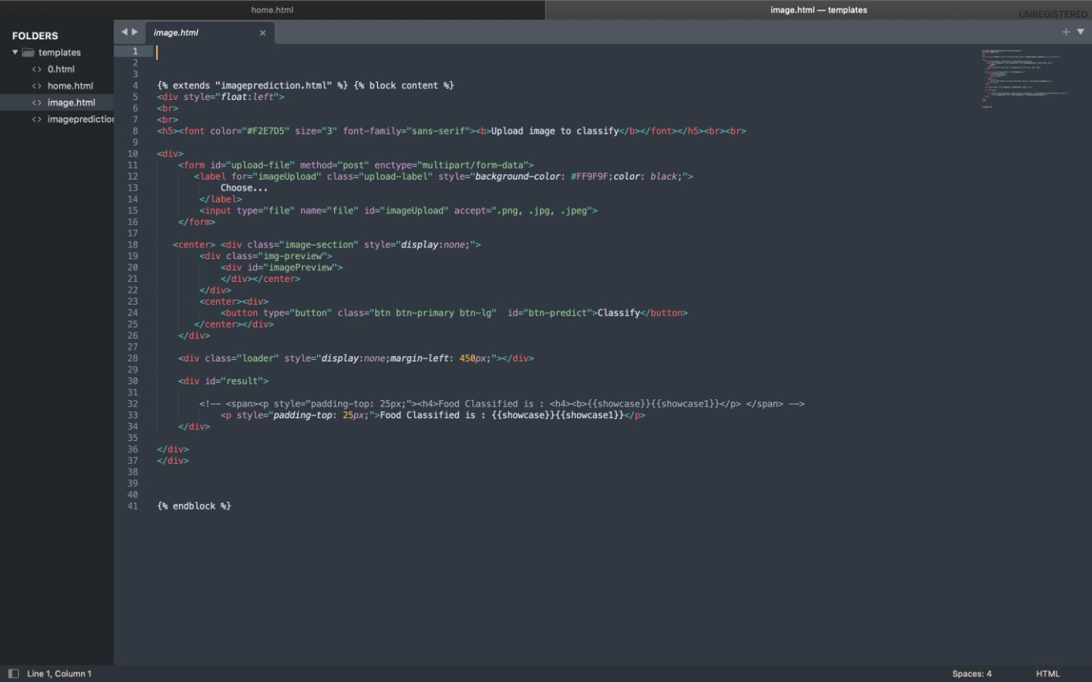

**8. TESTING**

* 1. **Test cases**

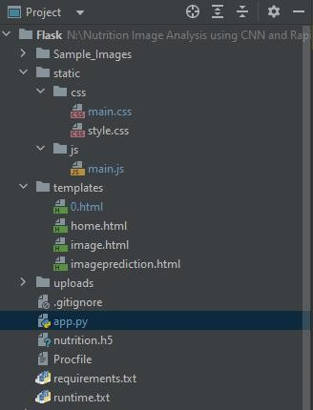

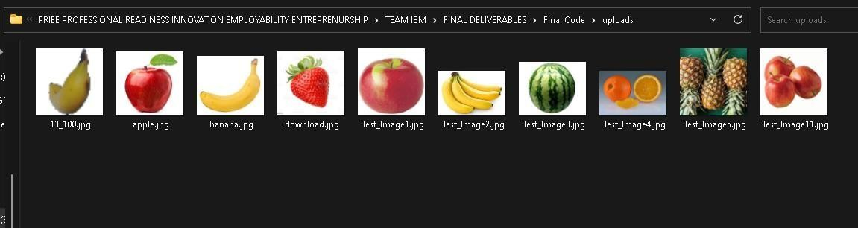

* 1. **User Acceptance Testing**

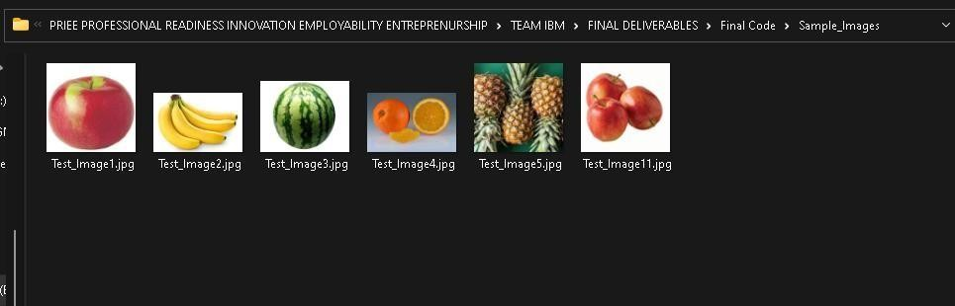

**9. RESULTS**

* 1. **Performance Metrics**

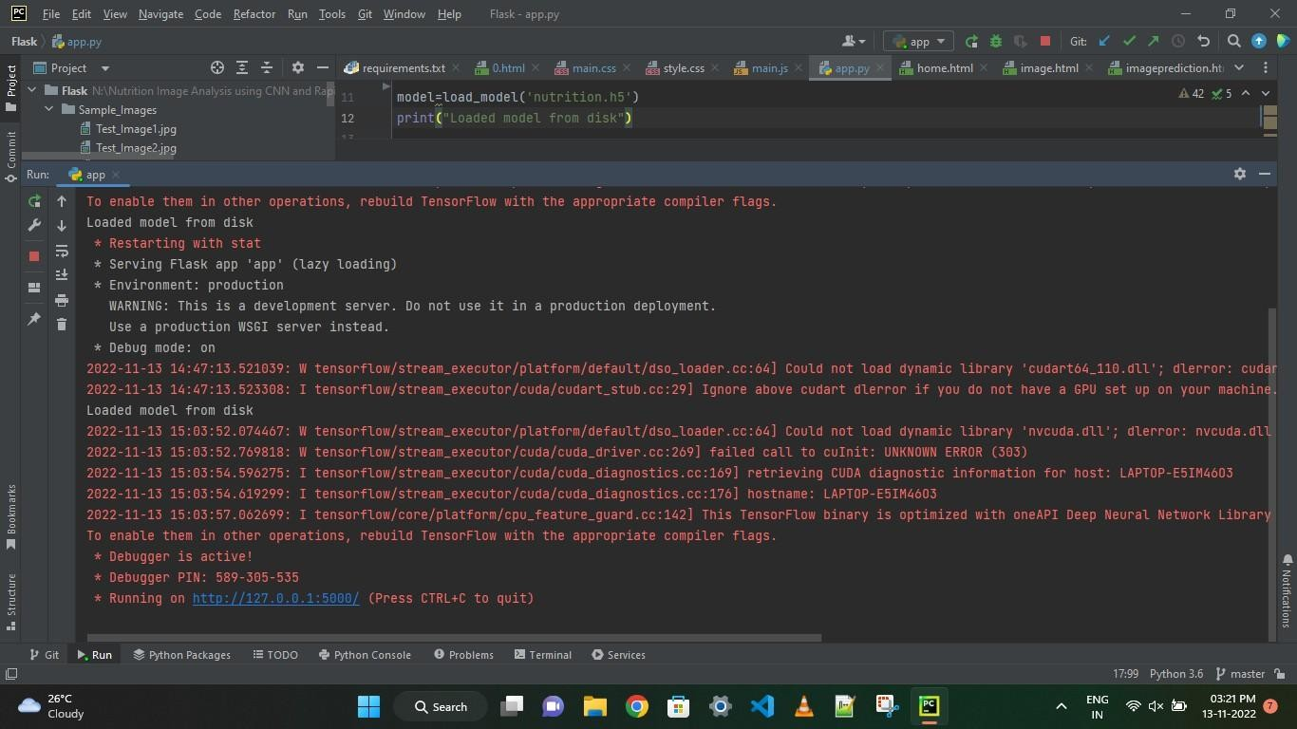

* 1. **Output**

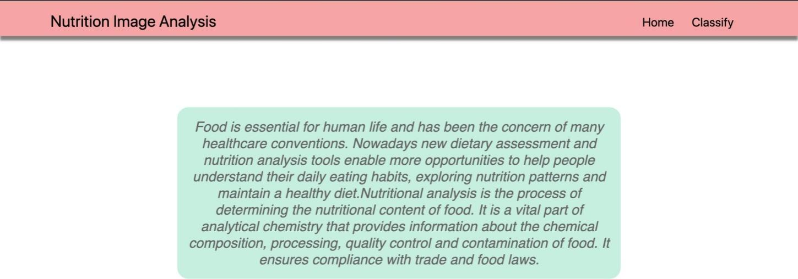

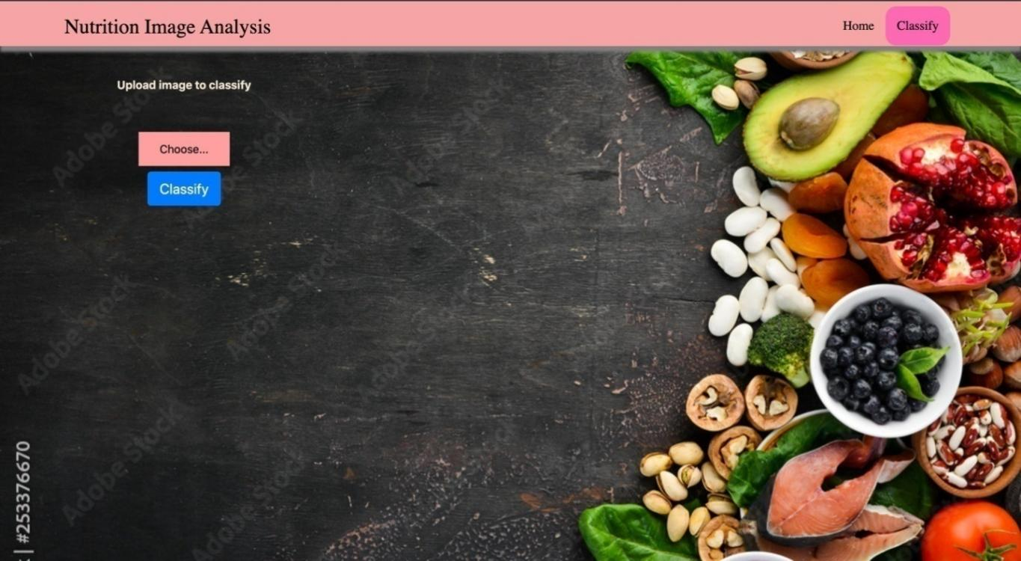

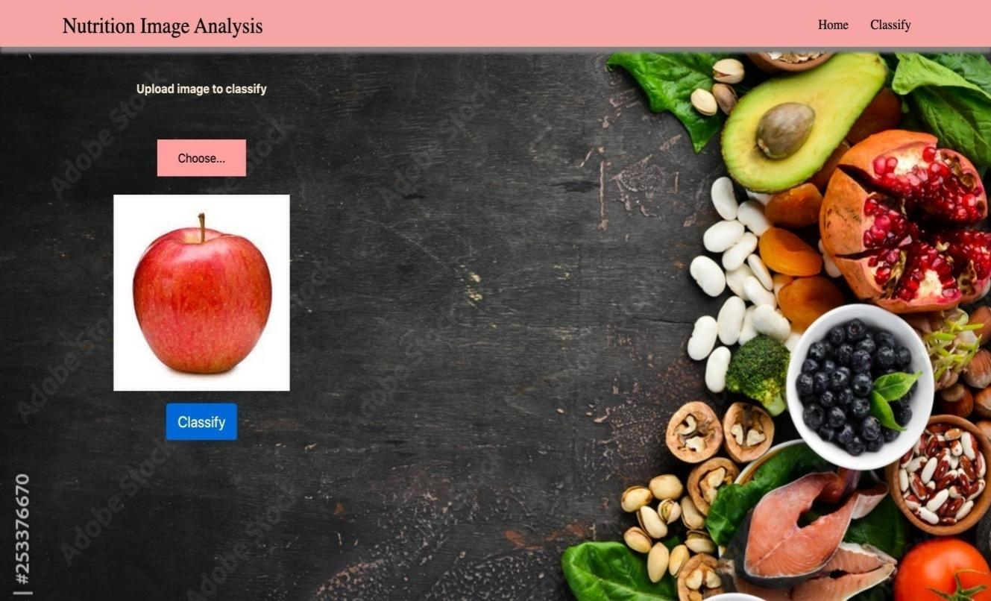

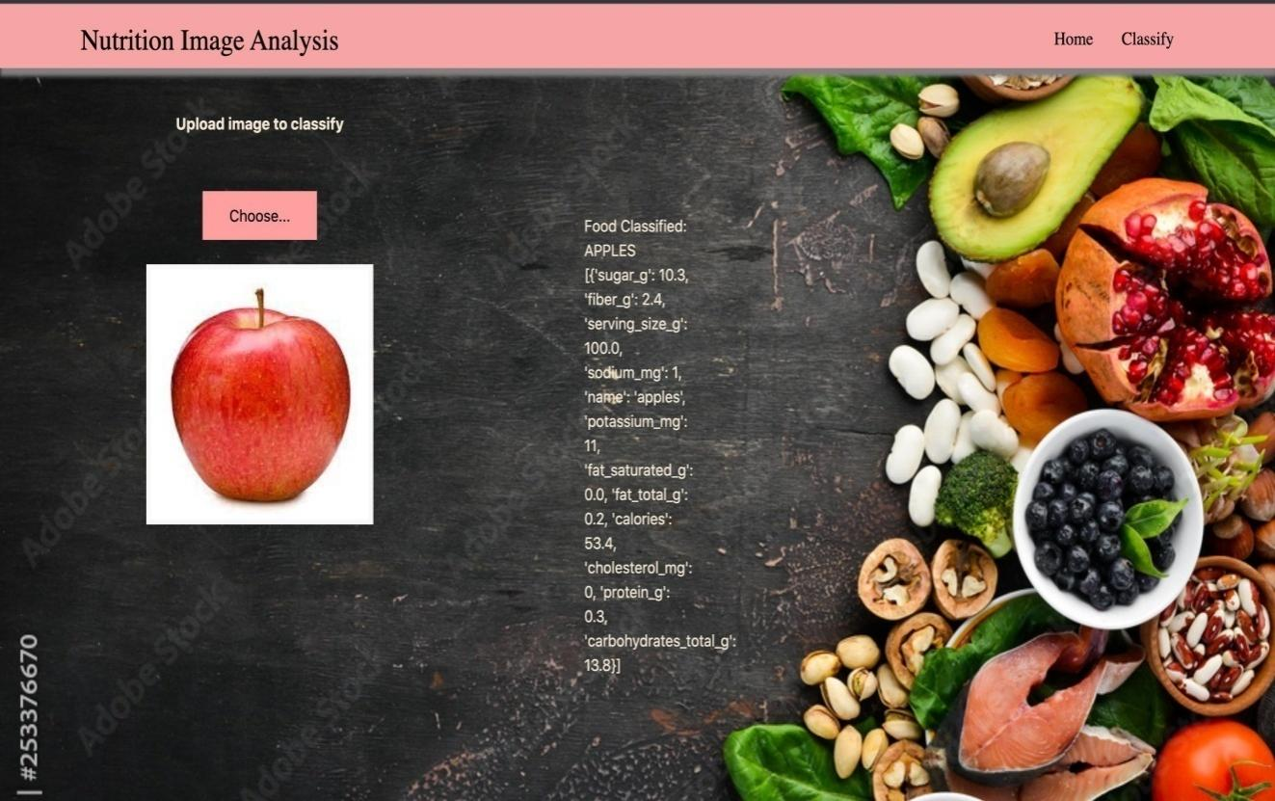

1. **ADVANTAGES AND DISADVANTAGES**

**ADVANTAGES:**

Artificial intelligence (AI) is a rapidly evolving area that offers unparalleled opportunities of progress and applications in many healthcare fields. AI-based approaches, including image recognition, may also improve dietary assessment by maximizing efficiency and addressing systematic and random errors associated with self-reported measurements of dietary intakes. Finally, AI applications can extract, structure and analyze large amounts of data from social media platforms to better understand dietary behaviors and perceptions among the population.

In summary, AI-based approaches will likely improve and advance nutrition research as well as help explore new applications. However, further research is needed to identify areas where AI does deliver added value compared with traditional approaches, and other areas where AI is simply not likely to advance the field. Novelty: Artificial intelligence offers unparalleled opportunities of progress and applications in nutrition. There remain gaps to address to potentialize this emerging field**.:**

**DISADVANTAGES:**

The main disadvantage of image recognition is its inability to work with low resolution, poor lighting, and complex backgrounds.

Image recognition is best suits scenarios where the image is clear, simple, and high resolution. Image recognition requires an object to be clearly visible in the input image and isn’t able to extract information from a complex background. It also requires a high-resolution image for accurate results.

Image recognition also struggles with different lighting conditions, where shadows or sunlight can make it difficult for the computer to correctly identify an object or person. Moreover, image recognition also requires a large amount of data for training the algorithm for accurate results, so it’s not ideal for identifying objects that are unique or uncommon.

1. **CONCLUSION**

Artificial intelligence (AI) as a branch of computer science, the purpose of which is to imitate thought processes, learning abilities and knowledge management, finds more and more applications. Thus, this process is further more used in this project to identify the nutrients contents of the fruits identified in the uploaded picture.

1. **FUTURE SCOPE**

There are many more such scopes in this project that could be added in this project as future scope. User’s body condition such as whether he has diabetes, cold, fever or any other body conditions that could be added while recommending the fruits to the user. High level intelligence is recommended while recognizing the image that are similar in appearance.

**13.APPENDIX**

**https://github.com/IBM-EPBL/IBM-Project-2425-1658471691**